HDPE resins (ExxonMobil)

ExxonMobil Chemical's extensive portfolio of high density polyethylene (HDPE) resins combines toughness and stiffness with resistance to environmental stress cracking at elevated temperatures and warping. Our high-molecular-weight (HMW) HDPE resins are designed for easy extrusion and a wide variety of applications including blow molding and injection molding.

[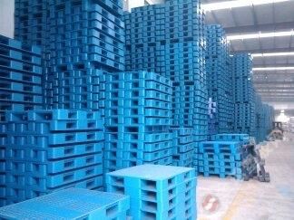](http://image.baidu.com/i?ct=503316480&z=&tn=baiduimagedetail&ipn=d&word=HDPE%E6%9D%90%E8%B4%A8%E4%BA%A7%E5%93%81&step_word=&ie=utf-8&in=30841&cl=2&lm=-1&st=-1&pn=2&rn=1&di=99092242620&ln=1998&fr=&&fmq=1392357663769_R&ic=0&s=&se=1&sme=0&tab=&width=&height=&face=0&is=&istype=2&ist=&jit=&objurl=http%3A%2F%2Fwww.51pla.com%2FSmallPic%2F2013%2F04%2F30%2Fa20130430212423815359.jpg)[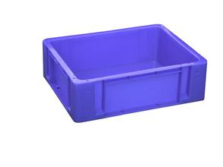](http://image.baidu.com/i?ct=503316480&z=&tn=baiduimagedetail&ipn=d&word=HDPE%E6%9D%90%E8%B4%A8%E4%BA%A7%E5%93%81&step_word=&ie=utf-8&in=3994&cl=2&lm=-1&st=-1&pn=82&rn=1&di=98018970830&ln=1998&fr=&&fmq=1392357663769_R&ic=0&s=&se=1&sme=0&tab=&width=&height=&face=0&is=&istype=2&ist=&jit=&objurl=http%3A%2F%2Fimg.zj123.com%2Fupload%2FuploadFile%2F2012%2F02%2F04%2F20120204102224218750.jpg)